Register No.

SRM INSTITUTE OF SCIENCE AND TECHNOLOGY
COLLEGE OF ENGINEERING & TECHNOLOGY
DEPARTMENT OF ELECTRONICS AND INSTRUMENTATION ENGINEERING
Cycle Test –I
Academic Year: 2025 - 26
________________________________________________________________________________________________________
Program offered: M.Tech Year / Sem: I/II
Course Title: CYBERSECURITY IN INDUSTRIAL AUTOMATION Max. Marks: 40
Course Code: 21EIE552T Duration: 2 Periods
Date of Exam:25/02/2025
_______________________________________________________________________________________________________
Course Articulation Matrix:
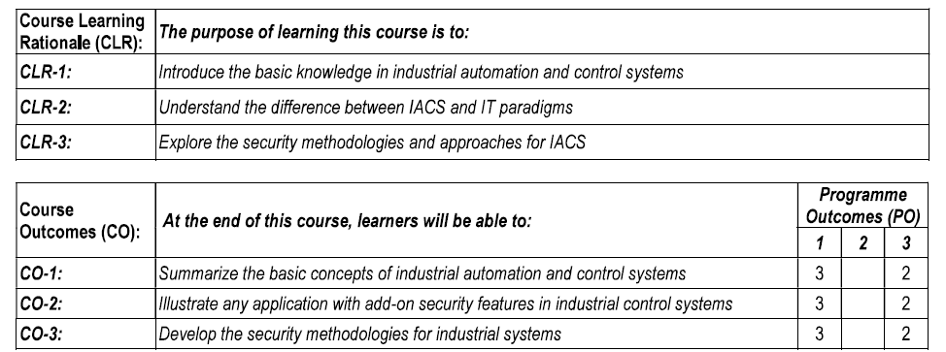
PART A
Answer ALL the questions
Sl.No | Question | Marks | CO | Blooms Level | PO | PI
1. | a) Describe the structure of Safety Instrumented Systems(SISs) of IACS with neat sketch. | 10 | 1 | 2 | 1 | 1.4.1
 | b) Explain the issues in IACS Security. | 10 | 1 | 2 | 1 | 1.4.1
 | (OR)
2. | a) Explain the block diagram of SCADA and DCS with neat sketch. | 10 | 1 | 2 | 1 | 1.4.1
 | b) Describe the industrial automation and control system protocols. | 10 | 1 | 2 | 1 | 1.4.1

3. | a)Describe the different types of firewalls used in information system security with neat sketch. | 10 | 1 | 2 | 1 | 1.4.1
 | b)Describe the malicious codes and types of cyberattacks against information systems and IACS. | 10 | 1 | 2 | 1 | 1.4.1
 | (OR)
4. | a)Explain the different types of cryptography technologies used in information system security with neat sketch. | 10 | 1 | 2 | 1 | 1.4.1
 | b)Describe the terminologies of Information System Security. | 10 | 1 | 2 | 1 | 1.4.1

